ACC, HIMSS and RSNA
Integrating the Healthcare Enterprise

IHE Patient Care Coordination Technical Framework

Supplement 2005-2006

Basic Patient Privacy Consents (BPPC)

Draft of Public Comment Version

<Comments due July 15, 2006>

Foreword
Integrating the Healthcare Enterprise (IHE) is an initiative designed to stimulate the integration of the information systems that support modern healthcare institutions. Its fundamental objective is to ensure that in the care of patients all required information for medical decisions is both correct and available to healthcare professionals. The IHE initiative is both a process and a forum for encouraging integration efforts. It defines a technical framework for the implementation of established messaging standards to achieve specific clinical goals. It includes a rigorous testing process for the implementation of this framework. And it organizes educational sessions and exhibits at major meetings of medical professionals to demonstrate the benefits of this framework and encourage its adoption by industry and users.
The approach employed in the IHE initiative is not to define new integration standards, but rather to support the use of existing standards, HL7, DICOM, IETF, and others, as appropriate in their respective domains in an integrated manner, defining configuration choices when necessary. IHE maintain formal relationships with several standards bodies including HL7, DICOM and refers recommendations to them when clarifications or extensions to existing standards are necessary.
This initiative has numerous sponsors and supporting organizations in different medical specialty domains and geographical regions. In North America the primary sponsors are the American College of Cardiology (ACC), the Healthcare Information and Management Systems Society (HIMSS) and the Radiological Society of North America (RSNA). IHE Canada has also been formed. IHE Europe (IHE-EUR) is supported by a large coalition of organizations including the European Association of Radiology (EAR) and European Congress of Radiologists (ECR), the Coordination Committee of the Radiological and Electromedical Industries (COCIR), Deutsche Röntgengesellschaft (DRG), the EuroPACS Association, Groupement pour la Modernisation du Système d'Information Hospitalier (GMSIH), Société Francaise de Radiologie (SFR), Società Italiana di Radiologia Medica (SIRM), the European Institute for health Records (EuroRec), and the European Society of Cardiology (ESC). In Japan IHE-J is sponsored by the Ministry of Economy, Trade, and Industry (METI); the Ministry of Health, Labor, and Welfare; and MEDIS-DC; cooperating organizations include the Japan Industries Association of Radiological Systems (JIRA), the Japan Association of Healthcare Information Systems Industry (JAHIS), Japan Radiological Society (JRS), Japan Society of Radiological Technology (JSRT), and the Japan Association of Medical Informatics (JAMI). Other organizations representing healthcare professionals are invited to join in the expansion of the IHE process across disciplinary and geographic boundaries.
The IHE Technical Frameworks for the various domains (IT Infrastructure, Cardiology, Laboratory, Radiology, etc.) defines specific implementations of established standards to achieve integration goals that promote appropriate sharing of medical information to support optimal patient care. It is expanded annually, after a period of public review, and maintained regularly through the identification and correction of errata. The current version for these Technical Frameworks may be found at www.ihe.net/Technical_Framework.
The IHE Technical Framework identifies a subset of the functional components of the healthcare enterprise, called IHE Actors, and specifies their interactions in terms of a set of coordinated, standards-based transactions. It describes this body of transactions in progressively greater depth. The volume I provides a high-level view of IHE functionality, showing the transactions organized into functional units called Integration Profiles that highlight their capacity to address specific clinical needs. The subsequent volumes provide detailed technical descriptions of each IHE transaction.
This supplement to the <IHE PCC Technical Framework V2.0> is submitted for Public Comment between <June 15, 2006 and July 15, 2006>, per the schedule announced in <February 2006>.

Comments shall be submitted before <July 15, 2006> to:
http://forums.rsna.org under the “IHE” forum
Select the “<PCC Supplements for Public Review>” sub-forum.

The IHE PCC Technical Committee will address these comments and publish the Trial Implementation version in <August 2006>.

Date: <June 30, 2006>
Author: Keith Boone, Lori Forquet, Rob Horn, John Moehrke
These ”boxed” instructions for the author to indicate to the Volume Editor how to integrate the relevant section(s) into the overall Technical Framework

Introduction
This Supplement provides a mechanism to record the patient privacy consent(s), a method to mark documents published to XDS with the patient privacy consent that was used to authorize the publication, and a method for XDS Consumers to use to enforce the privacy consent appropriate to the use.

Open Issues and Questions
- Not clear how we handle the case where a patient changes their mind on a consent. How does this affect the documents that are already published, already consumed by other enterprises in the Affinity Domain under the previous consent. The proposal is to handle all of these issues as manualy.
- This method does not try to communicate the meaning of the patient consent. This is expected to be a safe thing to communicate through manual configurations.

Closed Issues
< List of closed issues/ questions with their resolutions that have been addressed prior to publishing of the Technical Framework>

Profile Abstract
This Supplement provides a mechanism to record the patient privacy consent(s), a method to mark documents published to XDS with the patient privacy consent that was used to authorize the publication, and a method for XDS Consumers to use to enforce the privacy consent appropriate to the use.

GLOSSARY
Privacy Consent – This is where a patient gives up all pretense that he/she has any control over their healthcare data.

Volume I – Integration Profiles
<This section describes the changes required in Volume I of the Technical Framework that result form including this Integration Profile.>

Changes to Sections 1 – 1.X
<Include a subsection for each section/ subsection changed>

1.7 History of Annual Changes
<Brief description of what to add to Volume I, section 1.7 which gives a brief overview of “what’s new” in the given year of the Technical Framework.>
Add the following bullet to the end of the bullet list in section 1.7
- Added the BPPC Profile that provides for multiple privacy consents to be managed and acted upon.

Y <XYZ> Integration Profile Dependencies
Add the following section to Table 2-1 Integration Profiles Dependencies in section 2.1

Basic Patient Privacy Consents | XDS | Required to hold consent act and consent used to publish document | holds the patient consent act, and has metadata for each registered document indicating the ConfidentialityCode
Basic Patient Privacy Consents | XDP | Required to hold consent act and consent used to publish document | holds the patient consent act, and has metadata for each registered document indicating the ConfidentialityCode
Basic Patient Privacy Consents | XDS-SD | Required when patient uses wet signature | When the patient uses wet signatures (ink on paper), XDS-SD is used to capture the actual copy of the consent that the patient signs.

Add the following section to section 2.2

2.2.11 Basic Patient Privacy Consents (BPPC)
This Supplement provides a mechanism to record the patient privacy consent(s), a method to mark documents published to XDS with the patient privacy consent that was used to authorize the publication, and a method for XDS Consumers to use to enforce the privacy consent appropriate to the use.

The section shall be added to Vol 1

X BPPC Integration Profile
The document sharing infrastructure provided by XDS and XDP allow for the publication and use of clinical documents associated with a patient. This system requires that the Affinity Domain create and agree to a single policy (See IHE-ITI Vol 1:Appendix L). Today this means that much of the useful data is not entered into the XDS, or that the access to this data is too liberly allowed. This profile allows for the Affinity domain to have a small number of privacy consents. This allows for more flexibility to support some patient concerns, while providing an important and useful dataset to the healthcare provider.
Healthcare providers utalize many different sets of data to carry out the treatment, billing, and normal operations. When a patient presents, often the patient must fill out volumns of information used for patient demographics, contacts, and insurance. This information could be captured in XDS using a form of coded clinical document with an scanned image of the patient’s insurance card. This information is very useful to the administrative staff at the healthcare provider.
The patient when staying for a few days might have special dietary needs based on their conditions. This diatary needs could be documented in the XDS and marked as for clinical support staff. This document could be accessed by the diatition when preparing the meals.
The patient has other clinical data that is generally available for the patient’s direct care givers. This is the typical document that is found in the XDS today under the single policy.

X.1 Actors/ Transactions
<Actor/ Transaction diagram and Actor/ Transaction table. >
Figure X.1-1 shows the actors directly involved in the <XYZ> Integration Profile and the relevant transactions between them. Other actors that may be indirectly involved due to their participation in <other related profiles>, etc. are not necessarily shown.

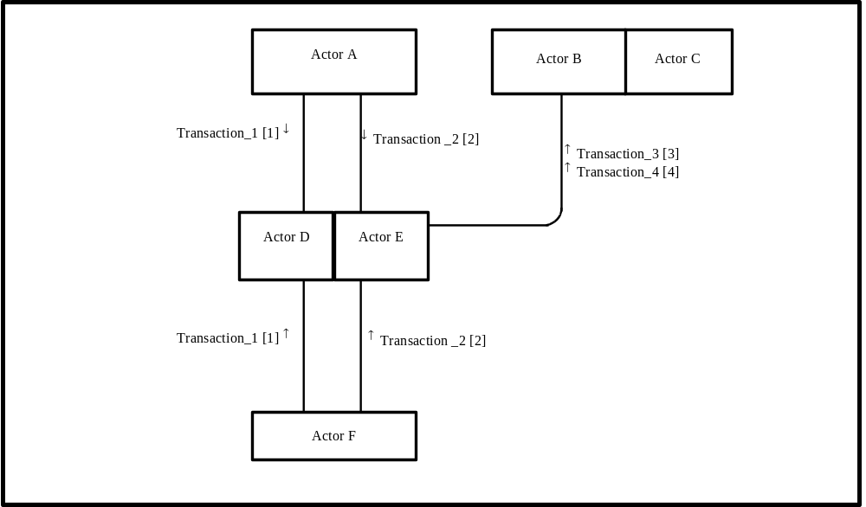
Figure X.1-1. <XYZ Profile> Actor Diagram
Table X.1-1 lists the transactions for each actor directly involved in the <XYZ> Profile. In order to claim support of this Integration Profile, an implementation must perform the required transactions (labeled “R”). Transactions labeled “O” are optional. A complete list of options defined by this Integration Profile and that implementations may choose to support is listed in Volume I, Section X.2.

Table X.1-1. <XYZ> Integration Profile - Actors and Transactions
Actors | Transactions | Optionality | Section in Vol. 2
Actor A | Transaction_1 | R | Z.1
Actor A | Transaction_2 | R | Z.2
Actor F | Transaction_1 | R | Z.1
Actor F | Transaction_2 | R | Z.2
Actor D/ Actor E | Transaction_1 | R | Z.1
Actor D/ Actor E | Transaction_2 | R | Z.2
Actor D/ Actor E | Transaction_3 | R | Z.3
Actor D/ Actor E | Transaction_4 | R | Z.4
Actor B (Actor C) | Transaction_3 | R | Z.3
Actor B (Actor C) | Transaction_4 | R | Z.4
Note: This is a note

X.2 <XYZ> Integration Profile Options
<Table describing the options available for this integration profile>
Options that may be selected for this Integration Profile are listed in the table X.2-1 along with the Actors to which they apply. Dependencies between options when applicable are specified in notes.
Table X.2-1 Evidence Documents - Actors and Options
Actor | Options | Vol & Section
Actor A | No options defined | - -
Actor F | No options defined | - -
Actor D/ Actor E | No options defined | - -
Actor D/ Actor E | No options defined | - -
Actor B (Actor C) | No options defined | - -
Actor B (Actor C) | No options defined | - -

X.3 <XYZ Integration Profile> Process Flow
<Description of the process flow(s) and sequence diagram(s) covered by this profile in order to satisfy the use cases. This often will include a brief description of the use cases as well. If there are detailed behavioral rules that apply to a specific process flow or multiple process flows or descriptions then an appendix may be added as needed>

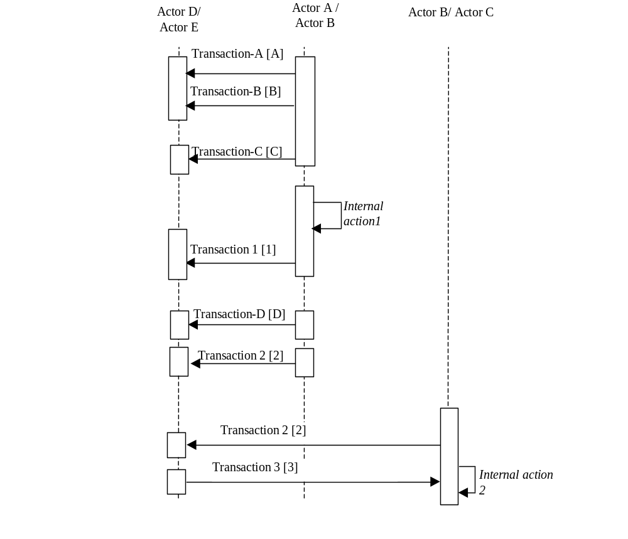
Figure X.2-1. Basic Process Flow in XYZ Profile
<Appendix A> Actor Summary Definitions
<add any actor definitions for new actors defined specifically for this profile>
<Appendix ???> Patient Consents Examples (Informative)
The document sharing infrastructure provided by XDS and XDP allow for the publication and use of clinical documents associated with a patient. This system requires that the Affinity Domain create and agree to a single policy (See IHE-ITI Vol 1:Appendix L). Today this means that much of the useful data is not entered into the XDS, or that the access to this data is too liberly allowed. This profile allows for the Affinity domain to have a small number of privacy consents. This allows for more flexibility to support some patient concerns, while providing an important and useful dataset to the healthcare provider.
This section gives examples of some possible patient privacy consent policies and how the systems publishing documents and using documents might act. This is an informative section and should not be interpreted as the only way to implement the BPPC profile.
The sprit of the privacy consents usecase would be captured in one or more legal documents that are vetted by the legal departments of all of the Affinity Domain enterprises. This legal document would be made available to all patients and systems involved in the Affinity Domain. The mechanism used to configure the systems (e.g. EHR, PACS) to meet this Policy is not defined in this profile. This symantic interoperability will likely be the subject of future IHE profiles as the standards and their implementations become available.
A.???.1 Administrative Use
Healthcare providers utalize many different sets of data to carry out the treatment, billing, and normal operations. When a patient presents, often the patient must fill out volumns of information used for patient demographics, contacts, and insurance.
For this example we might illustrate a registration system that captures a scanned image of the patient’s insurance card. This scanned image can be submitted to the XDS using the confidentiality code indicating that it is available for administrative uses. This registration system could additionally capture the typical demographics and such in a form of coded clinical document that is also published as available for administrative use. Both of these documents don’t have clinical information and thus wouldn’t need to be restricted to direct care providers.
Now that we have shown how this information can be captured. We can see cases where the patient presents at a different clinic in the same Affinity Domain. The administrative staff can now query the XDS and simply confirm that the information is the same.
A.???.2 Clinical Support Staff Use
The patient when staying for a few days might have special dietary needs based on their conditions. This diatary needs could be documented in the XDS and marked as for clinical support staff. This document could be accessed by the diatition when preparing the meals.
A.???.3 Direct Care Provider Use
The patient has other clinical data that is generally available for the patient’s direct care givers. This is the typical document that is found in the XDS today under the single policy.

